Competitive Shooters of Lake Norman USPSA February 13th, 2026
COURSE DESIGNER: Ike Starnes
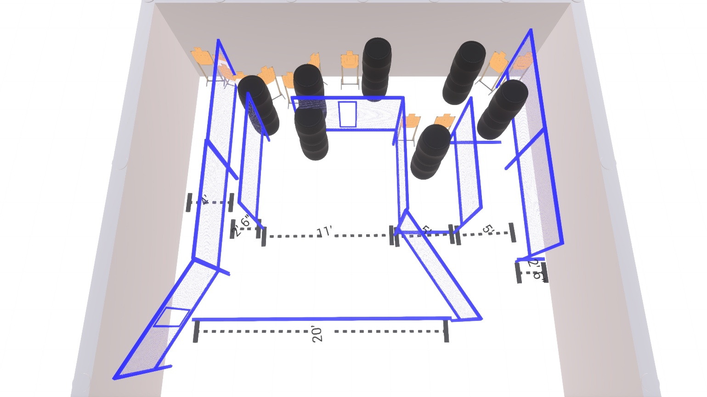

Stage 1 – It’s St. Paddy’s Day. Everyone’s Irish tonight.
26 rounds, 130 points, Comstock
There are 13 cardboard targets with some no-shoots.
Starting inside the shooting area.
Handgun is loaded and holstered, wrists below belt.
PCC is loaded held in both hands, stock touching belt.
On the audible start signal, engage targets from within the shooting area.

